- Create one VPC, with 1 public subnet and 1 private subnet.
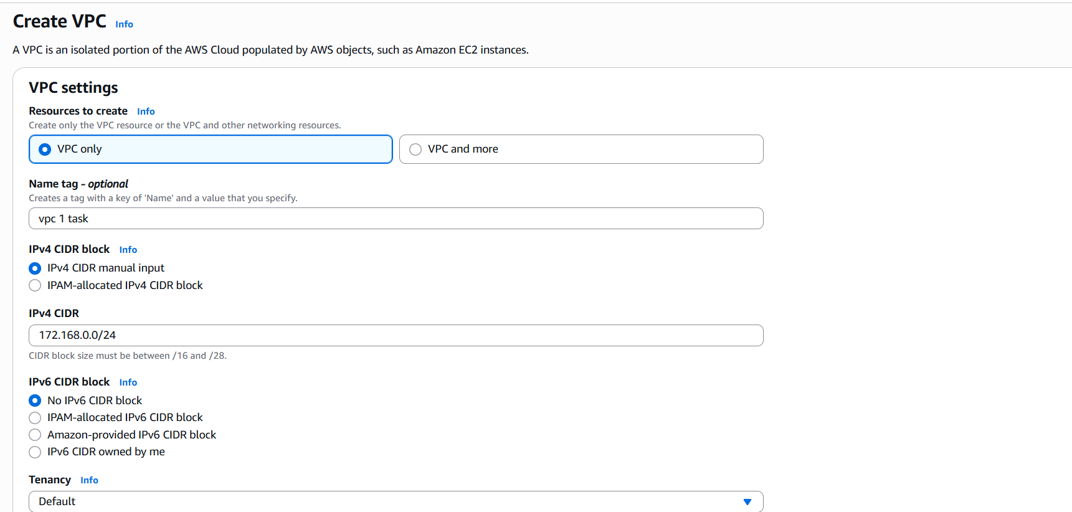
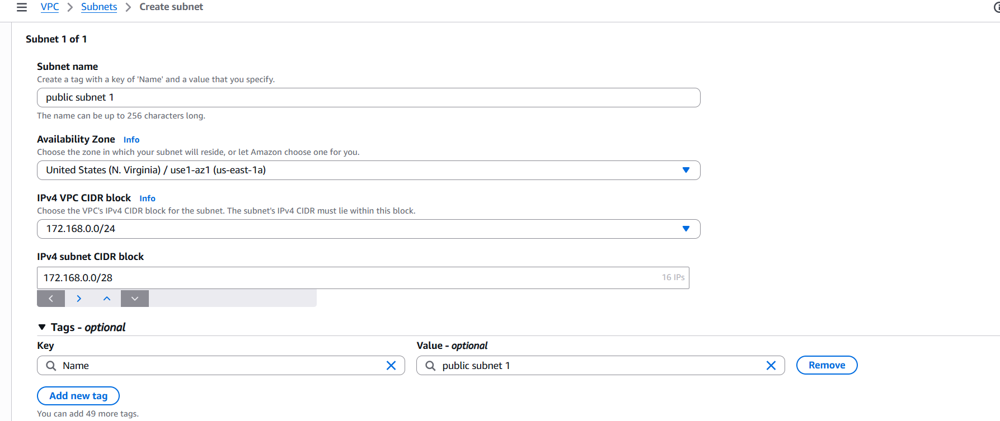
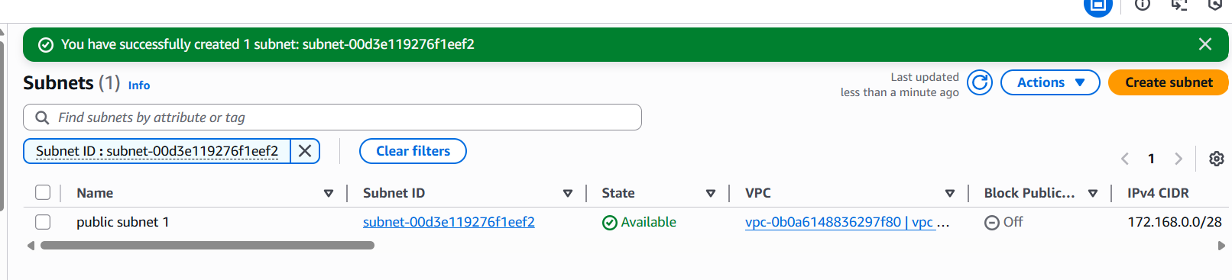
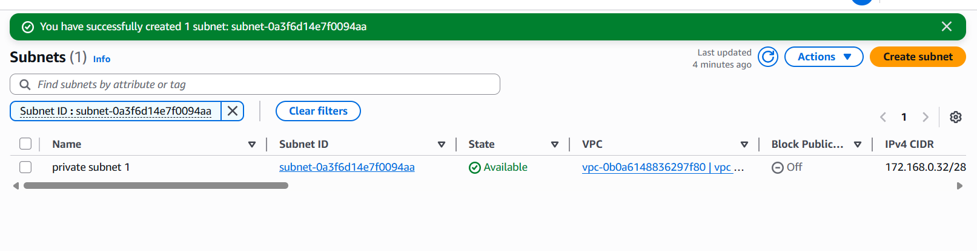
- Enable VPC peering for cross-region.
first create vpc in both regions which you want to create
vpc cidr rage should be different for both regions
create one public and private subnet in both region
create route tables for both public and private subnets
add internet gateway to the public subnet and add subnet associations for one public and private for private route table in both regions
after making all changes
create peering connection
add the name for it
select vpc-select another region-
now go to another region, whatever you created vpc select the vpc id and paste it in peering connection
finally crate now…. after that go to another region and accept the request
peering has been done successfully
now create an instance in new region and add public subnet to it and launch instance
now go the git bash-paste the ssh link
for adding keypem details
give cat and which keypem you have given
copy the data and paste it in vi test.pem
and add permissions chmod 600 test.pem
ssh -I test.pem ec2-user@paste the private id
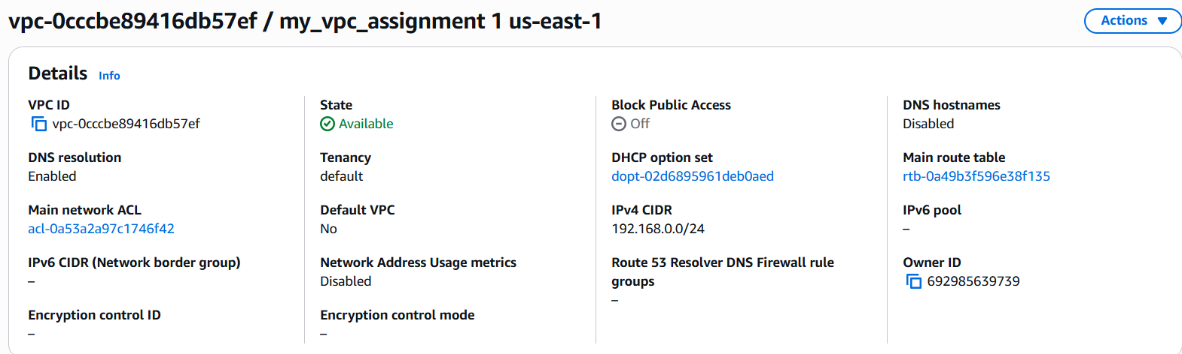
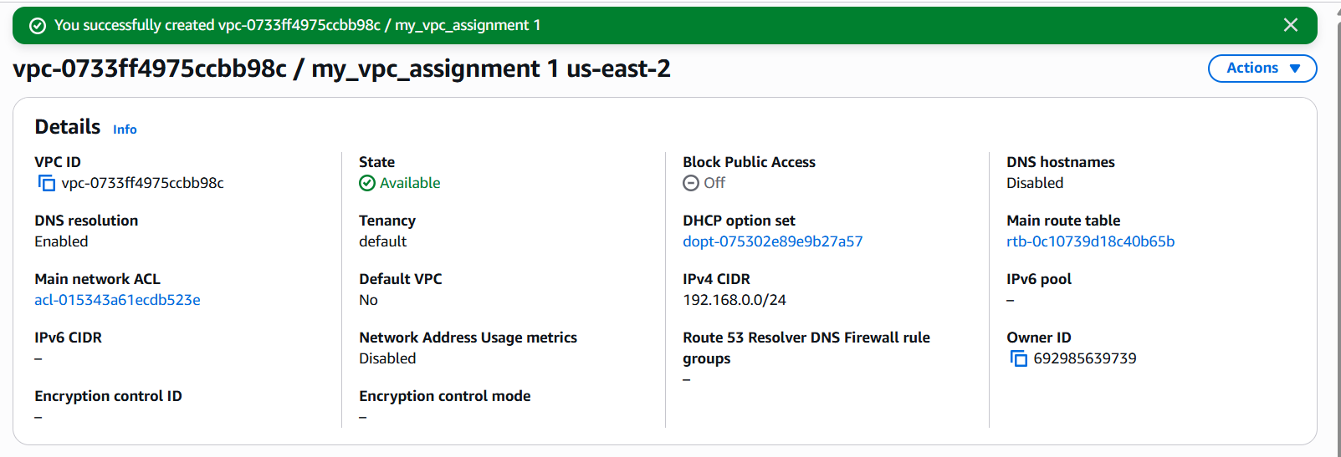
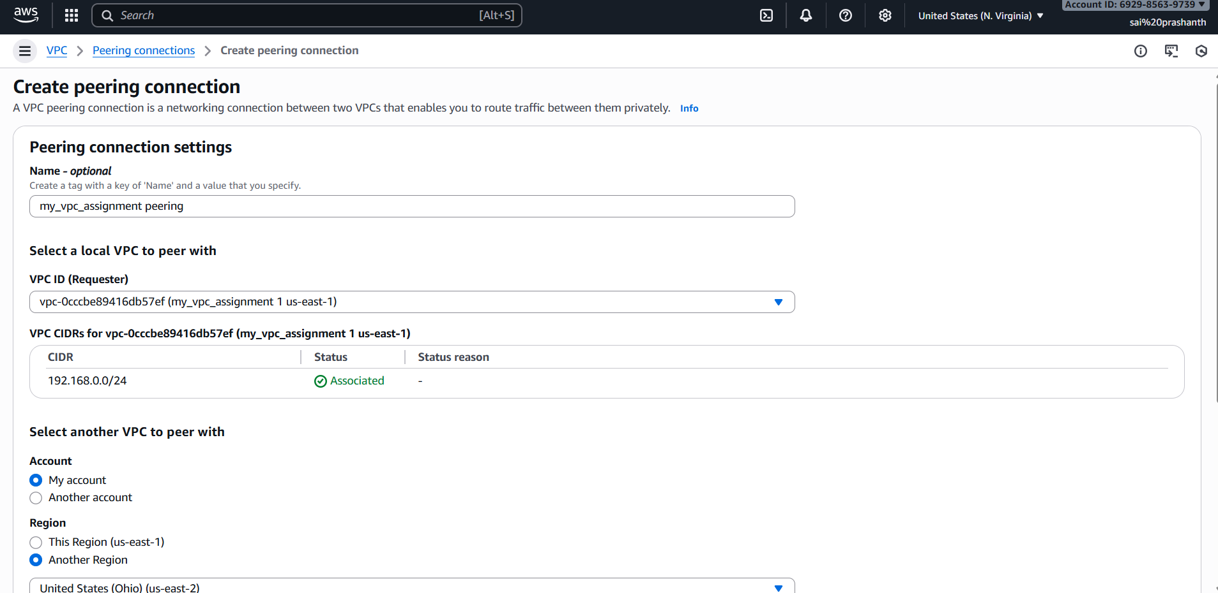
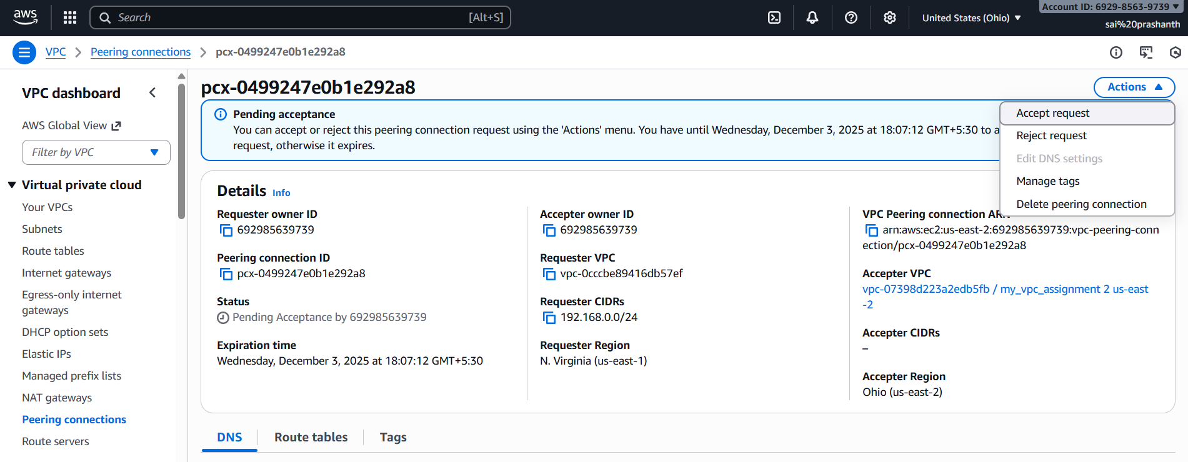
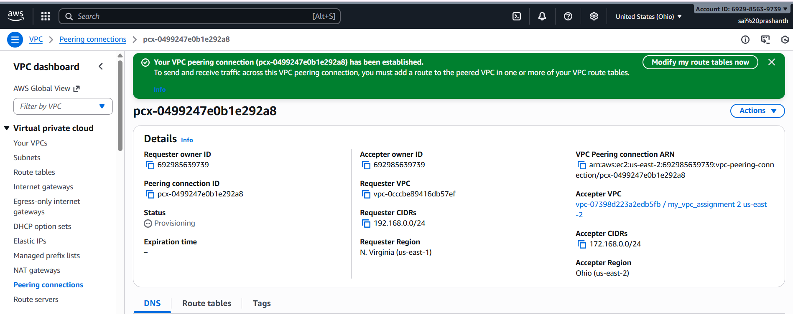
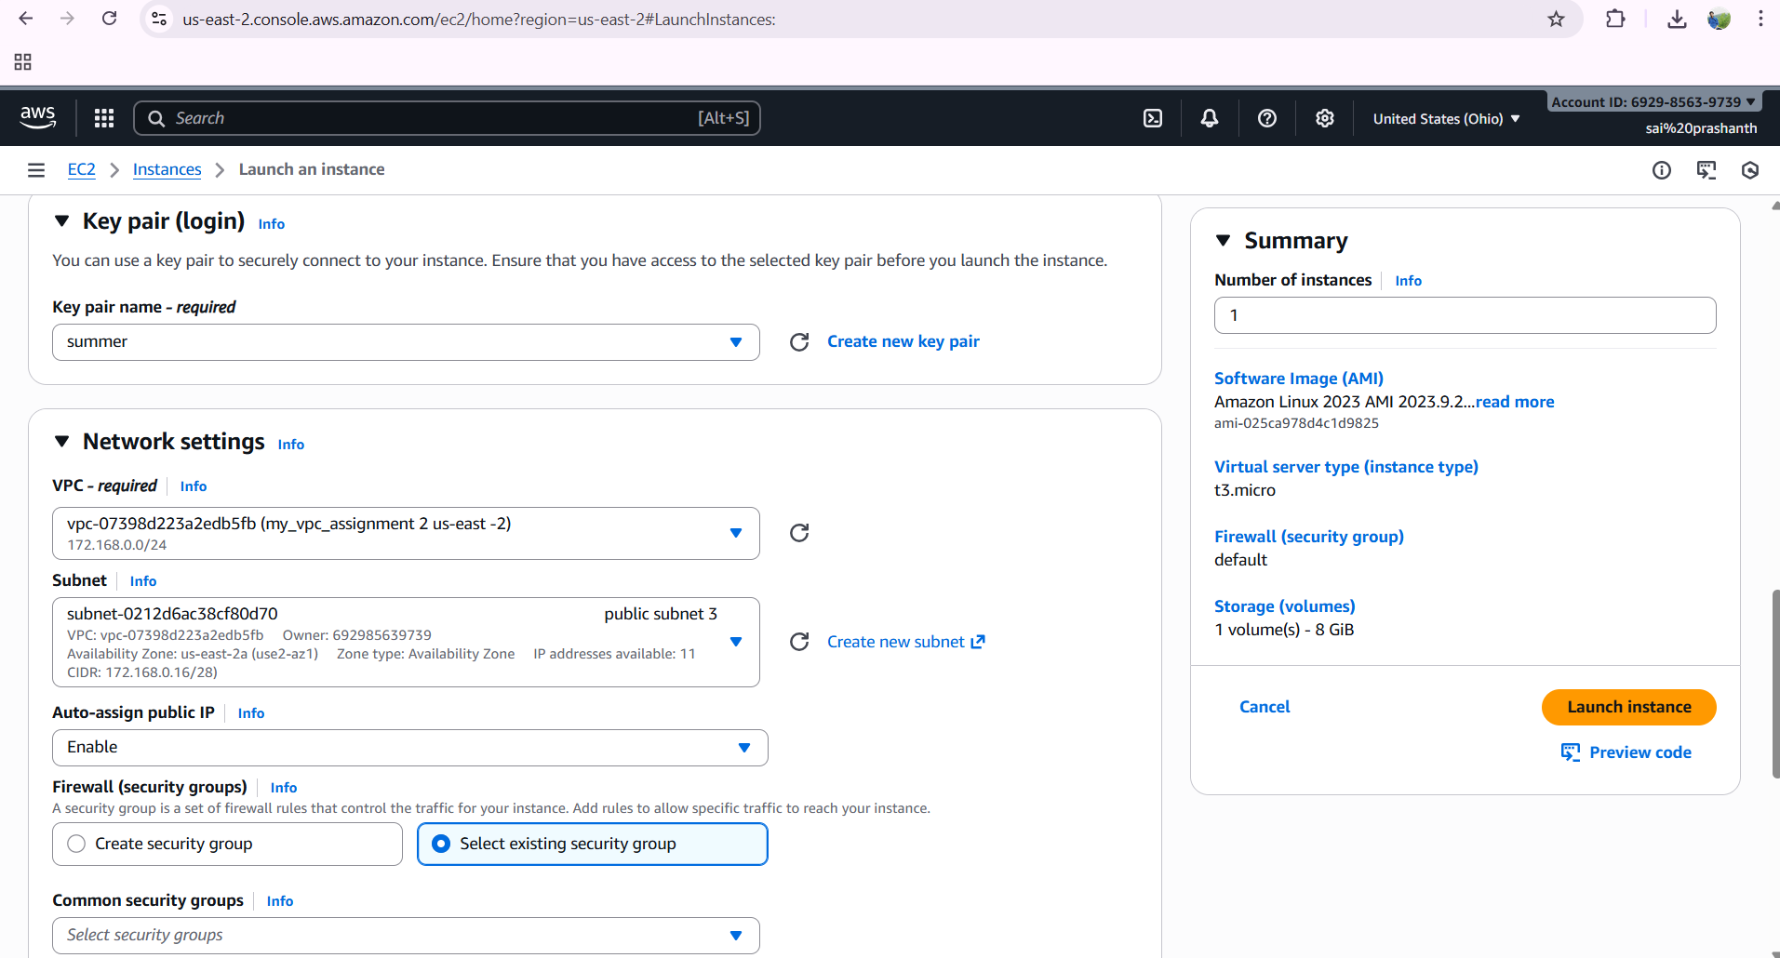
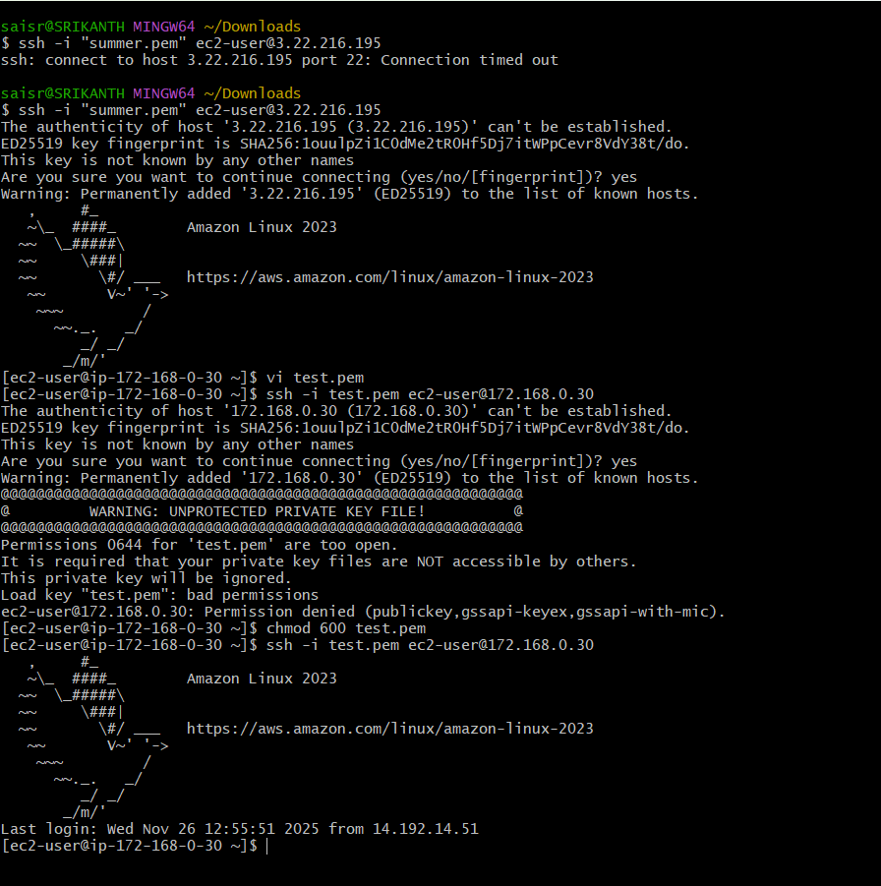
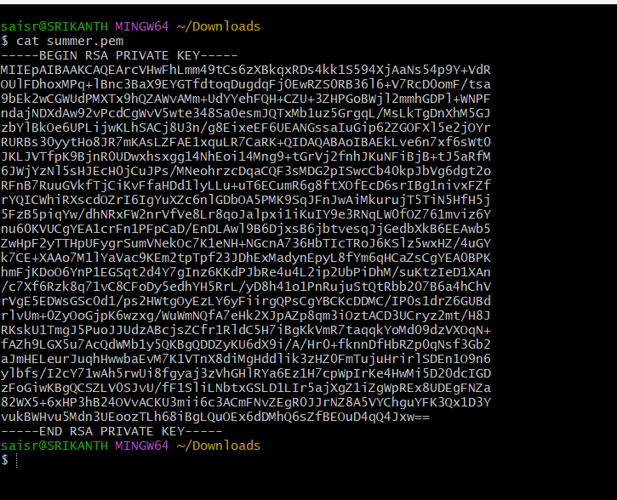

- Enable VPC peering for cross-account (you can collaborate with your friend to do this task).
first click on peering connection
click on create peering connection
enter name
select vpc which you created before only
to whom you are peering enter his account id number and vpc id of which he is created
enter the region which he is created
ensure that both cidr should be different
now click on create peering
once it has been successful , ask him to accept the request
now launch an instance and add public subnet to it and select the vpc
now connect ssh in gitbash
you need to give his peering id and cidr range number of his in public route table which you have created
now in gitbash enter ping and entetr the private ip address of him
now press enter
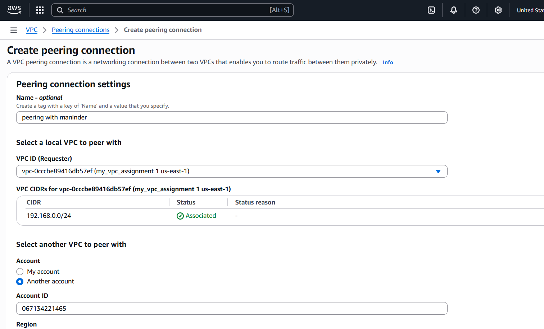
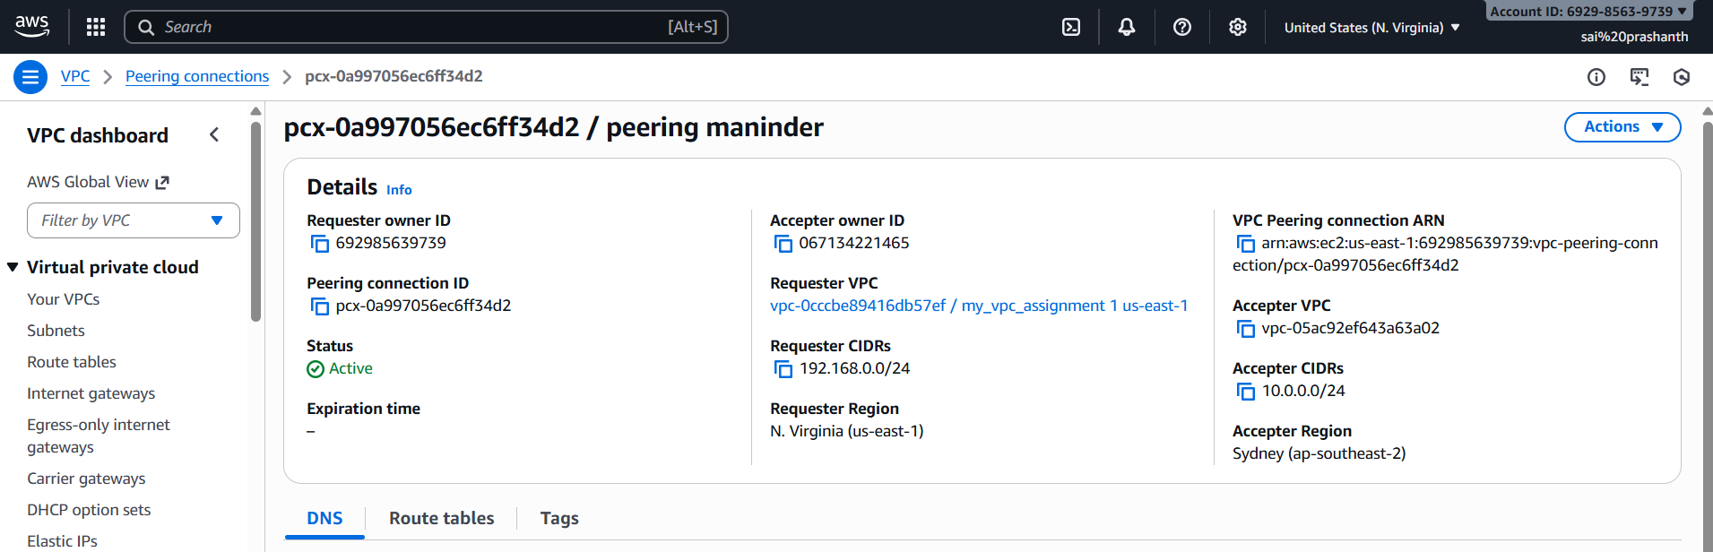
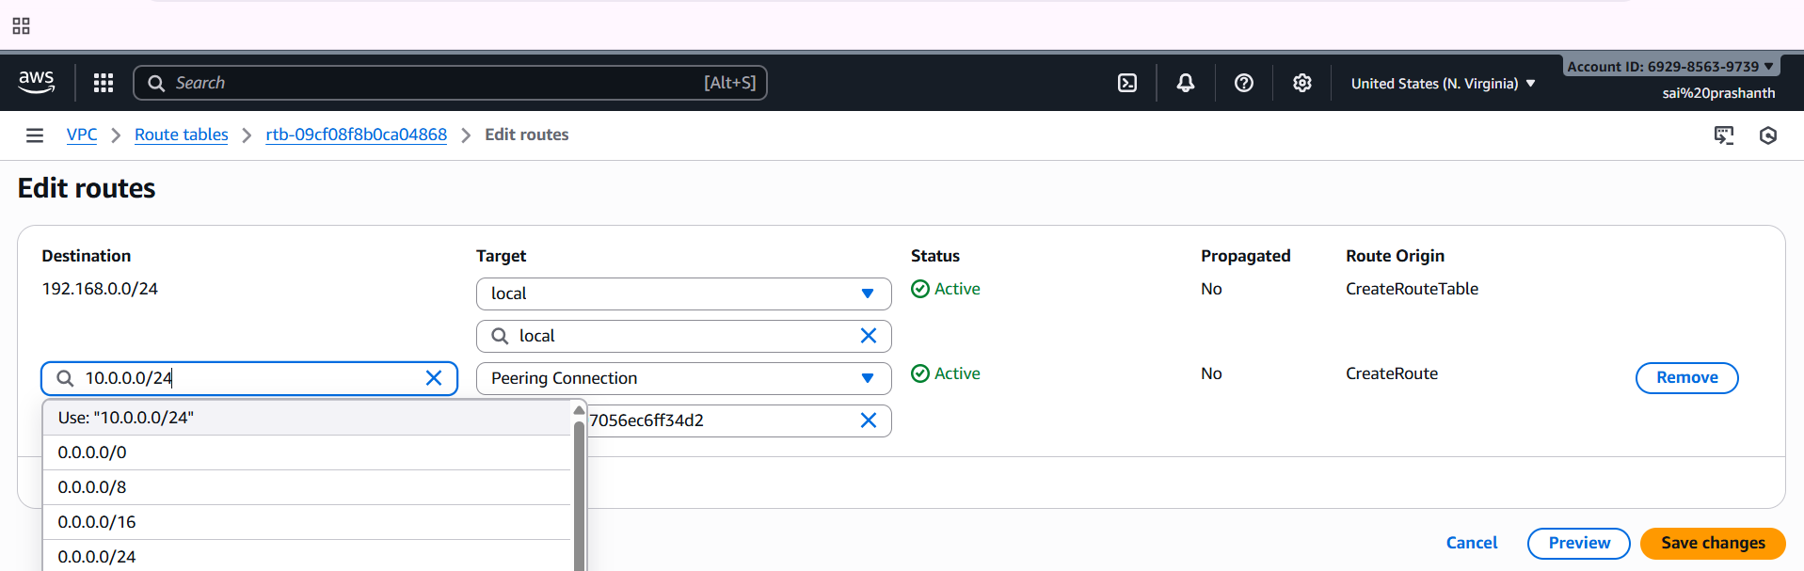
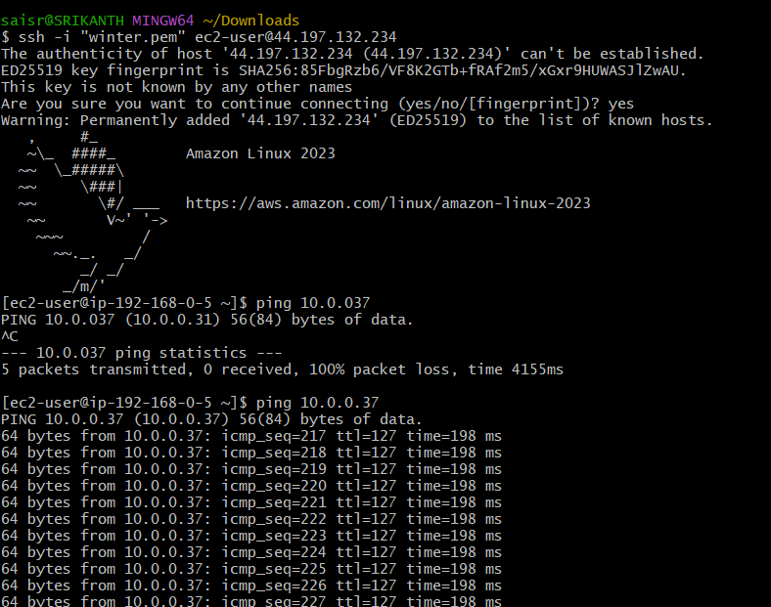

- Set up a VPC Transit Gateway.
first, we nee to create transit gateway
then we need to create 4 vpcs naming vpc 1,2,3,4
then we need to create 4 transit gateway attchments
then we need to create 4 route tables and agttach each route table to 1,2,3 and 4
4 subnets and add it to subnet associations in the route table
then create 4 instances naming ec2-01,2,3,4 and select each vpc for ec21-1 ,following the same
now in git bash connect one instance by adding security group permissions ,should give all traffic with custom 0000
now connect with ec2 instance -01 and copy the ec2 private ip
now run the command ping ec2-02 private ip
check the same with all instances with different instance private ip’s
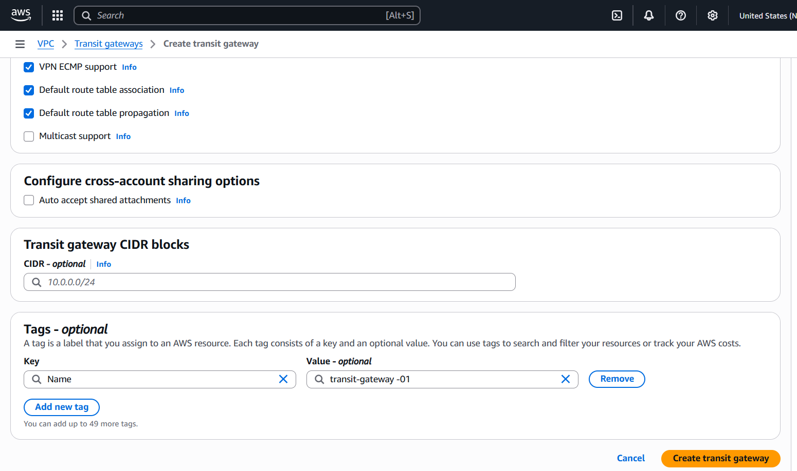
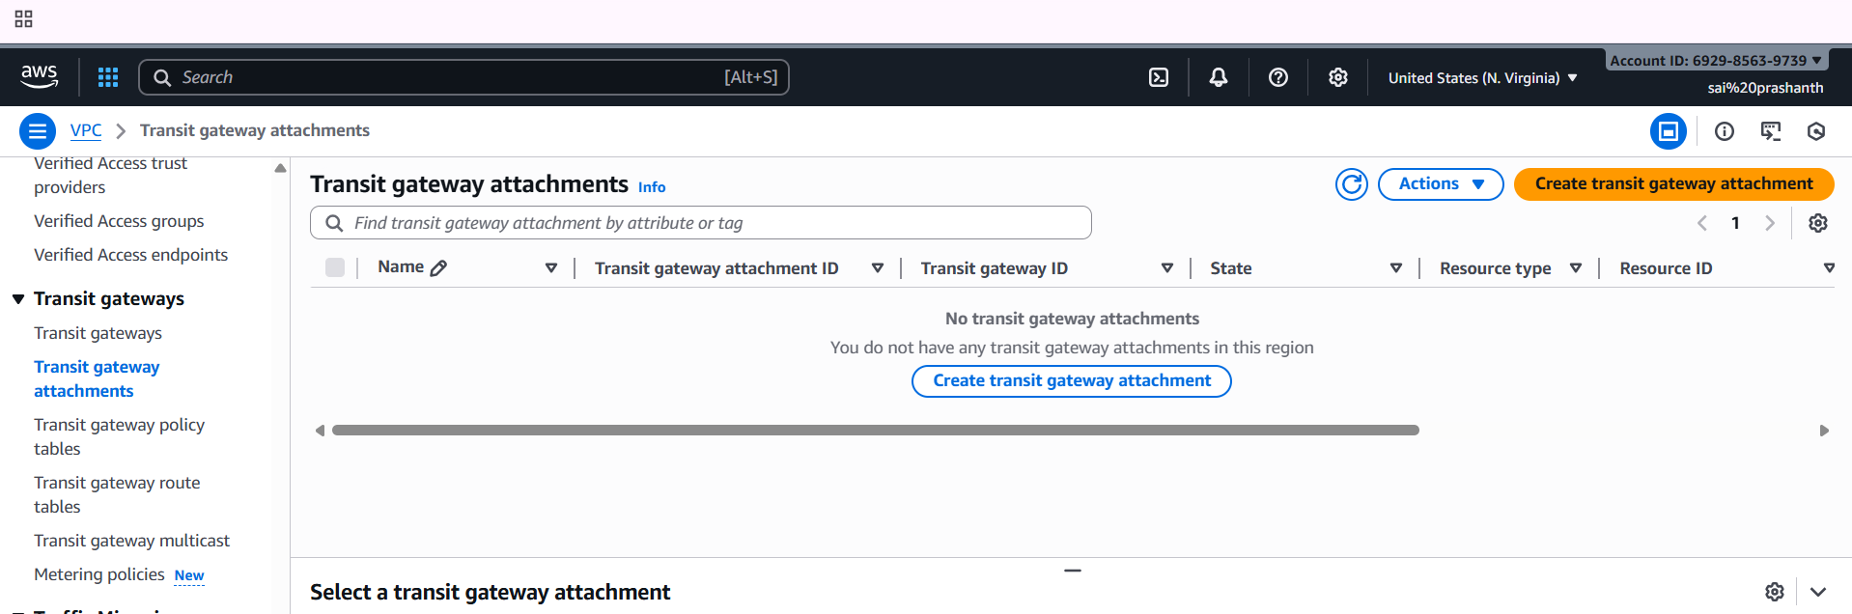

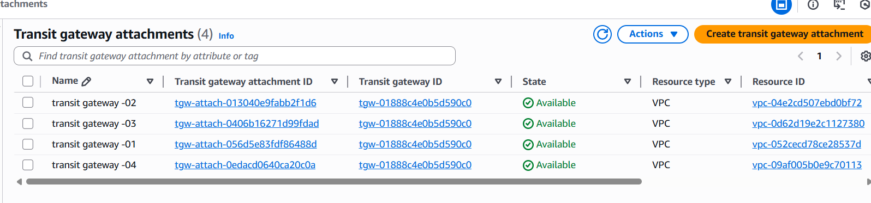
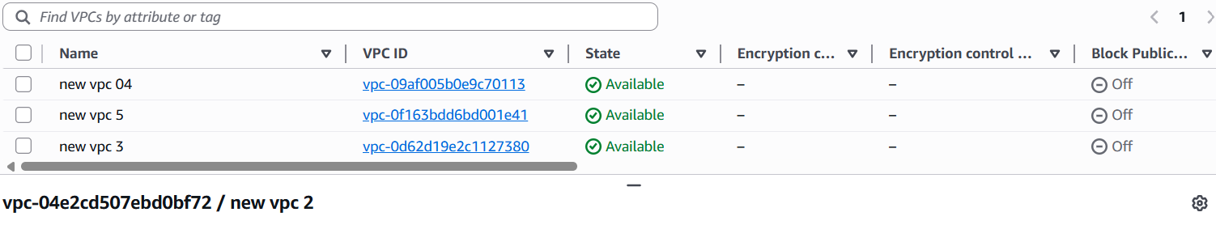
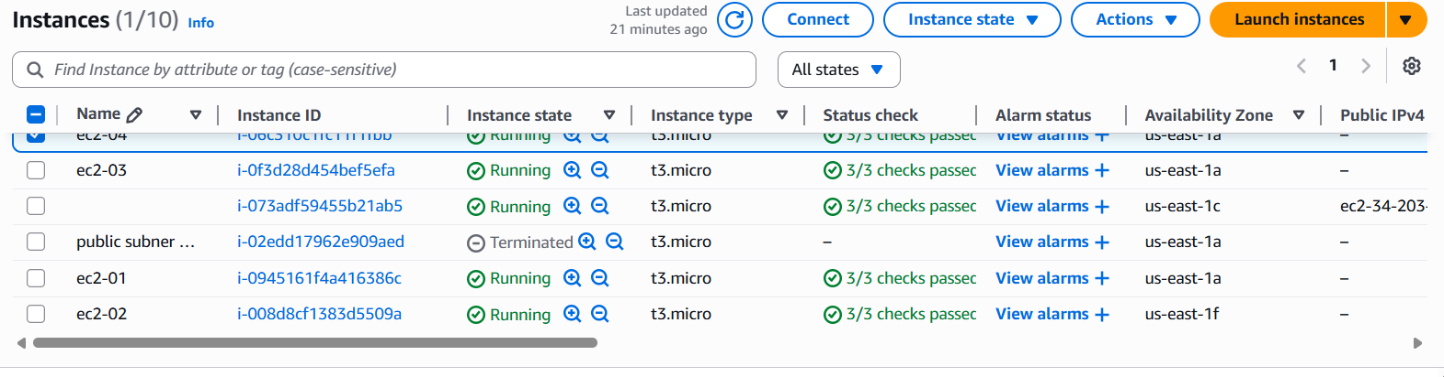
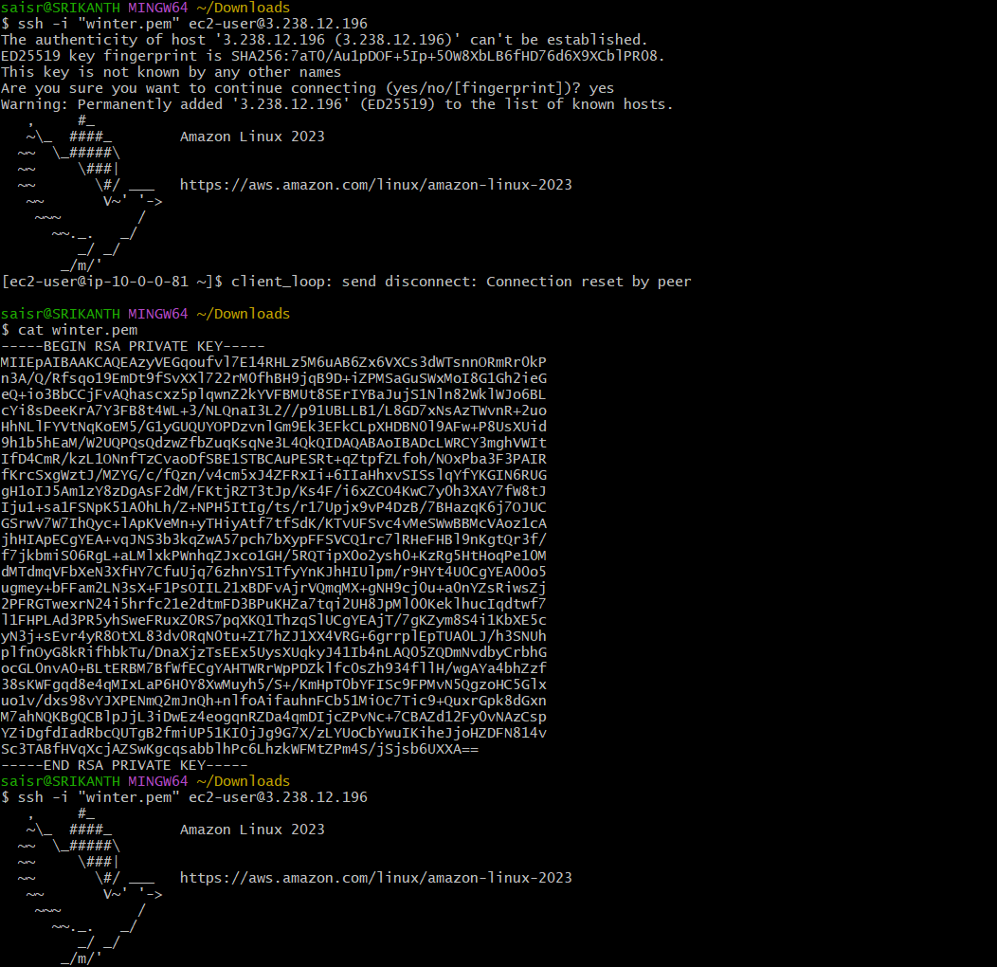
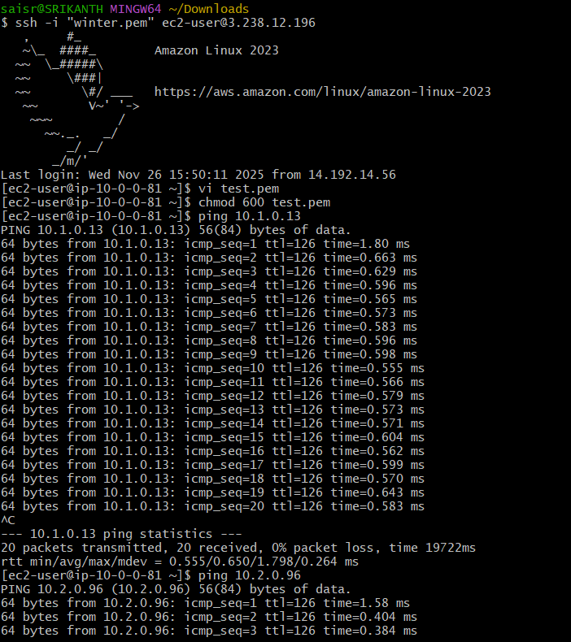

- Set up a VPC Endpoint.
first create one vpc,public subnet and private subnet
create route tables one for public and private and add subnet associations accordingly
create internet gateway to the public subnet and attach to vpc and edit routes in public route table and make changes
now create a bucket in s3 by adding the unique name
before creating the instance download the access key and secret key for getting the aws configure
now create two instances one for public and one for private
now try to connect in git bash
connect with public instance ssh -i……
now aws configure
enter access key
secret key
region
output format -json
now to list the buckets
aws s3 ls
you can see the buckets list
now to connect with private ip with private instance
copy your pemkey data
and paste it in vi test.pem
and add permissions chmod 600 test.pem
ssh -I test.pem ec2-user@private ip
now if do aws configure and aws s3 ls
it doesn’t display – reason is that private instance didn’t have internet access or nat gateway access and there is no way of knowing if s3 bucket exists
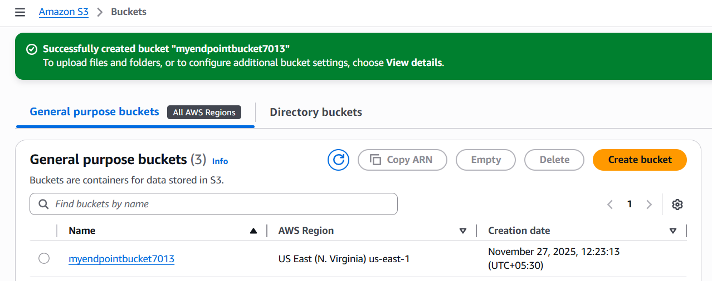
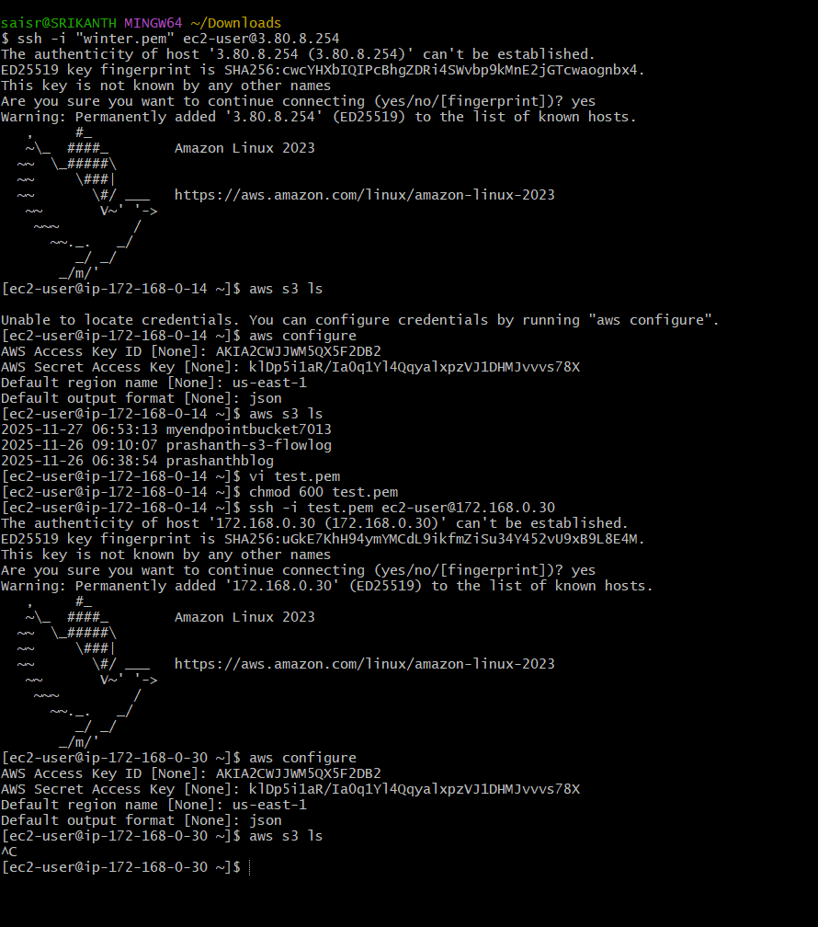
now to create endpoint
select endpoint-create end point—provide one end point name—select the type AWS services—select the region—select the service s3—select the service type gateway—select vpc—in route table select the private route table—policy select full access and create the end point.
finally end point has been created
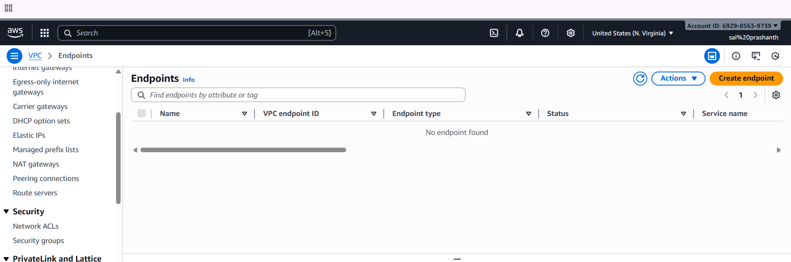
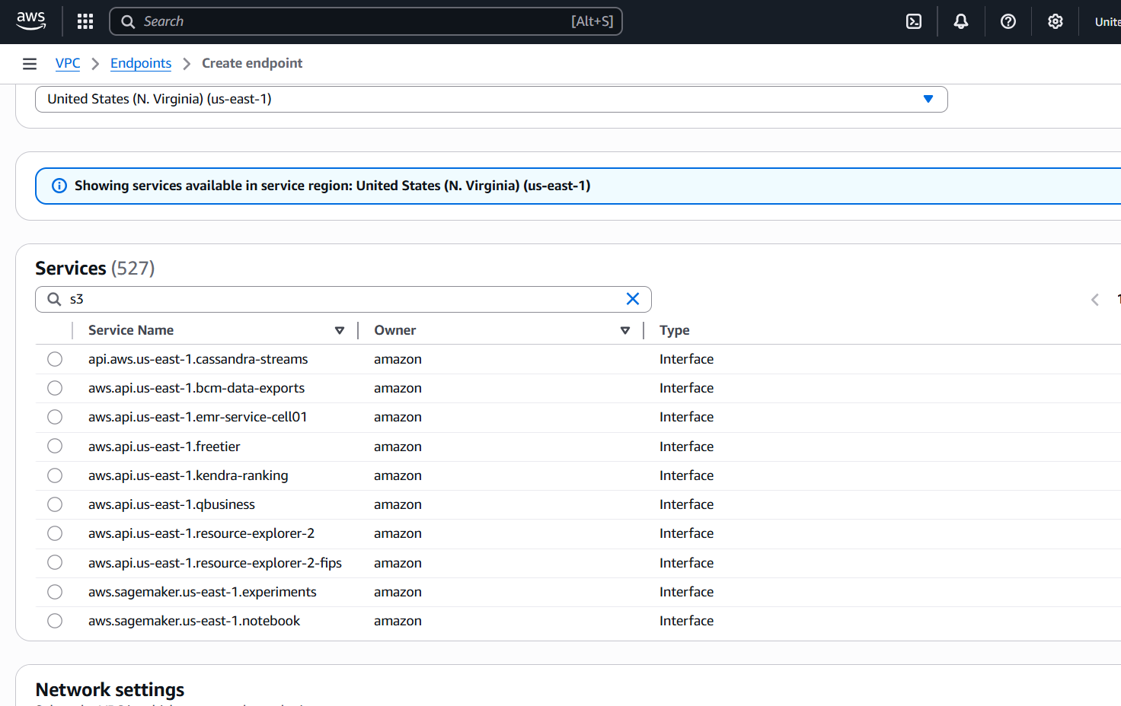
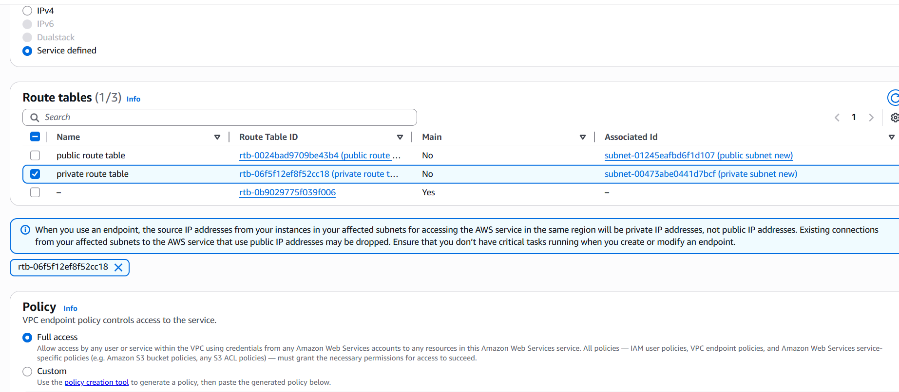
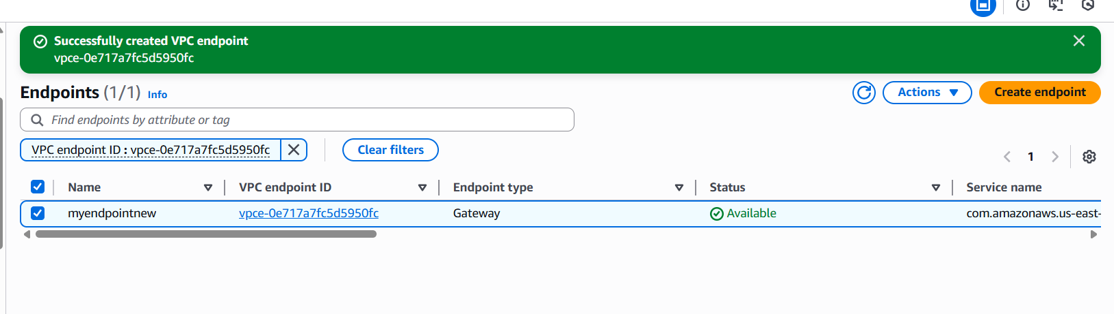
now in git bash
try to access with private ip now
now we have established private connection to end point so we can see the s3 bucket list
aws s3 ls
